 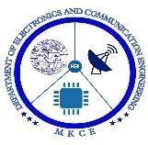 

**IOT BASED AIR POLLUTION MONITORING SYSTEM**

**A MINOR PROJECT -I REPORT**

**SUBMITTED BY**

**HARIKUMARESAN S 927621BEC060**

**DHARANEESH V L 927621BEC036**

**GUHANRAJ P K 927621BEC056**

**HARIHARAN M 927621BEC059**

**BACHELOR OF ENGINEERING**

**In**

**DEPARTEMENT OF ELECTRONIC AND COMMUNICTAION ENGINEERING**

**M.KUMARASAMY COLLEGE OF ENGINEERING**

**(Autonomous)**

**KARUR-639113**

**DECEMBER 2022**

**M.KUMARASAMY COLLEGE OF ENGINEERING**

**KARUR**

**BONAFIDE CERTIFICATE**

Certified that this 18ECP103L- Minor Project 1 report “**AN IOT BASED AIR POLLUTION MONITORING SYSTEM**” the bonafide work of “ **HARIKUMARESAN S(927621BEC060), DHARANEESH V L (927621BEC036), GUHANRAJ P K (927621BEC056), HARIHARAN M (927621BEC059)**”who carried out the project work under my supervision in the academic year 2022-2023.

**SIGNATURE SIGNATURE**

Dr.S.PALANIVELRAJAN,M,E.,Ph.D., Mr.P.RAMAKRISHNAN ,M.E.,(Ph.D).,

**HEAD OF THE DEPARTMENT, SUPERVISOR**

Professor, Assisant Professor,

Department of Electronics and Department of Electronics and

Communication Engineering, Communication Engineering,

M.Kumarasamy College of Engineering, M.Kumarasamy College of Engineering,

Thalavapalayam, Thalavapalayam,

Karur-639113. Karur-639113.

This project report has been submitted for the **18CB103L-Minor Project 1** viva voice Examination held at M,Kumarasamy College of Engineering,Karur on ____________________

**PROJECT COORDINATOR**

# Vision and Mission of the Institute and Department

**Vision**

To emerge as a leader among the top institutions in the field of technical education.

# Mission

* Produce smart technocrats with empirical knowledge who can surmount the globalchallenges.
* Create a diverse, fully-engaged, learner-centric campus environment to provide qualityeducation to the students.
* Maintain mutually beneficial partnerships with our alumni, industry and professionalassociations.

# Department of Electronics and Communication Engineering

**Vision**

* To empower the Electronics and Communication Engineering students with Emerging Technologies, Professionalism, Innovative Research and Social Responsibility. **Mission**
* Attain the academic excellence through innovative teaching learning process, researchareas & laboratories and Consultancy projects.
* Inculcate the students in problem solving and lifelong learning ability.
* Provide entrepreneurial skills and leadership qualities.
* Render the technical knowledge and industrial skills of faculties.

# PROGRAM EDUCATIONAL OBJECTIVES (PEO'S)

**PEO1:** Graduates will have a successful career in academia or industry associated with electronics and communication engineering.

**PEO2:** Graduates will provide feasible solutions for the challenging problems through comprehensive research and innovation in the allied areas of electronics andcommunication engineering.

**PEO3:** Graduates will contribute to the social needs through lifelong learning,practicing professional ethics and leadership quality

# PROGRAM OUTCOMES(PO'S)

**PO1: Engineering knowledge:** Apply the knowledge of mathematics, science, engineering fundamentals, and an engineering specialization to the solution of complexengineering problems **PO2: Problem analysis:** Identify, formulate, review research literature, and analyze complex engineering problems reaching substantiated conclusions using first principlesof mathematics, natural sciences, and engineering sciences

**PO3: Design/development of solutions:** Design solutions for complex engineering problems and design system components or processes that meet the specified needs with appropriate consideration for the public health and safety, and the cultural, societal, and environmental considerations

**PO4: Conduct investigations of complex problems:** Use research-based knowledge and research methods including design of experiments, analysis and interpretation of data, and synthesis of the information to provide valid conclusions

**PO5: Modern tool usage:** Create, select, and apply appropriate techniques, resources, and modern engineering and IT tools including prediction and modeling to complex engineering activities with an understanding of the limitations

**PO6: The engineer and society:** Apply reasoning informed by the contextual knowledge to assess societal, health, safety, legal and cultural issues and the consequent responsibilities relevant to the professional engineering practice

**PO7: Environment and sustainability:**Understand the impact of the professional engineering solutions in societal and environmental contexts, and demonstrate theknowledge of, and need for

sustainable development

**PO8: Ethics :**Apply ethical principles and commit to professional ethics and responsibilities and norms of the engineering practice

**PO9: Individual and team work:** Function effectively as an individual, and as a member or leader in diverse teams, and in multidisciplinary settings

**PO10: Communication:** Communicate effectively on complex engineering activities with the engineering community and with society at large, such as, being able to comprehend and write effective reports and design documentation, make effectivepresentations, and give and receive clear instructions

**PO11: Project management and finance:** Demonstrate knowledge and understanding of the engineering and management principles and apply these to one‘s own work, as a member and leader in a team, to manage projects and in multidisciplinary environments

**PO12: Life-long learning:** Recognize the need for, and have the preparation and abilityto engage in independent and life-long learning in the broadest context of technologicalchange.

# PROGRAM SPECIFIC OUTCOMES(PSO'S)

**PSO1**: Applying knowledge in various areas, like Electronics, Communications, Signal processing, VLSI, Embedded systems etc., in the design and implementation of Engineering application.

**PSO2**: Able to solve complex problems in Electronics and Communication Engineeringwith analytical and managerial skills either independently or in team using latest hardware and software tools to fulfil the industrialexpectations

# MAPPING OF PROJET WITH POs AND PSO

|  |  |
| --- | --- |
| **Abstract** | **Matching with Pos,PSOs** |
| EMBEDDED SYSTEM | PO1,PO2,PO7,PO8,PSO1 |

**ABSTRACT**

IOT Based Air Pollution Monitoring System is used to monitor the Air Quality over a web server using Internet cloud , It means when there are sufficient amount of harmful gases present in the air like CO2, smoke, alcohol, benzene, NH3 and N0X , etc. the gas sensor detects and send the signal to the node MCU board. The board update the output of the sensor to the cloud and the air quality is shown. The air quality is keep on updated in the cloud.

**Keywords:** Mq135 sensor, nodeMCUboard.

|  |  |  |
| --- | --- | --- |
| **FIGURE NO** | **LIST OF FIGURES**  **TITLE** | **PAGE NO** |
| 1 | Block Diagram | 10 |
| 2 | Schematic Diagram | 11 |
| 3 | ESP8266NOD MCU Board | 12 |
| 4 | OLED Board | 12 |
| 5 | MQ135 Sensor | 13 |
| 6 | Bread Board | 14 |
| 7 | Arduino Board | 16 |
| 8 | Thing Speak Cloud | 16 |

**LIST OF ABBREVIATIONS**

IOT - Internet of Things AQIOT - Air Quality web of Things

LORAWAN - Long Vary Wide Space Network CO - Carbon mono Oxide

IDE - Integrated Development Environment USB - Universal Serial Bus

PPM - Parts Per Million

AQI - Air Quality Index

# TABLE OF CONTENTS

|  |  |  |
| --- | --- | --- |
| **Chapter**  **No.** | **Particulars** | **Page No.** |
|  | Vision and mission of the Institution and Department | 1 |
|  | Mapping of project with POs and PSOs | 3 |
|  | Abstract | 4 |
|  | List of Figure | 5 |
|  | Acronyms/List of abbreviation | 6 |
| 1. | Introduction | 8 |
| 2. | Literature Review | 8 |
| 3. | Existing method | 9 |
| 4. | Proposed Method | 10 |
| 5 | Block Diagram | 10 |
| 6 | Circuit Diagram | 11 |
| 7 | Components | 11 |
| 8 | workflow | 14 |
| 8.1 | Phase 1 | 14 |
| 8.2 | Phase 2 | 15 |
| 8.3 | Phase 3 | 15 |
| 9 | Conclusion | 15 |
| 10 | References | 16 |

1. **INTRODUCTION**

Air pollution is contamination of the indoor or out of doors atmosphere by any chemical, physical or agent that modifies the natural characteristics of the atmosphere. social unit combustion devices, motorized vehicles, industrial facilities and forest fires area unit common sources of pollution. Pollutants of major public health concern embrace material, carbon monoxide gas, ozone, gas and pollutant. out of doors and indoor pollution cause metabolic process and different diseases and area unit vital sources of morbidity and mortality. World Health Organization information show that just about all of the worldwide population (99%) breathe air that exceeds World Health Organization guideline limits and contains high levels of pollutants, with low- and middle-income countries plagued by the best exposures. Air quality is closely joined to the earth‘s climate and ecosystems globally. several of the drivers of pollution (i.e. combustion of fossil fuels) are sources of gas emissions. Policies to cut back pollution, therefore, supply a win-win strategy for each climate and health, lowering the burden of malady as a result of pollution, yet as tributary to the near- and long mitigation of global climate change. This document is example. we have a tendency to raise that authors follow some straightforward pointers. In essence, we have a tendency to raise you to create your paper the net has become omnipresent associate degreed standard in nearly each corner of the world and has effects on human life in an unthinkable method. therefore we have a tendency to area unit currently getting into associate degree era of "Internet of Things (IOT)". It includes ancient computing devices like laptops, tablets and smartphones, however additionally includes a growing list of different devices that have recently become web enabled. Examples embrace home appliances, cars, wearable physical science, security cameras and plenty of different things. so as for a tool to be a part of the net of Things, it should be able to communicate with different devices. Therefore, it needs some form of intrinsic wired or wireless communication. Most IOT devices area unit Wi-Fi enabled, however Bluetooth can also be used to transfer information to close devices. IOT devices area unit usually known as ―smart devices‖, since they are able to communicate with different things. at the side of the capability to talk, several IOT devices additionally embrace associate degree array of sensors that give helpful data. whereas the net of Things continues to be in its infancy, it provides promising opportunities for the longer term.

# LITERATURE REVIEW

According to ,air quality assurance could be a terribly massive concern for humanity, particularly for folks living in urban areas. A custom protrusible Air Quality web of Things (AQIOT) device platform is capable of creating measurements and stores all collected knowledge within the cloud.

The parts employed in the primary version of the device value around US$900 greenbacks and ar supported a Raspberry Pi3 Model B. This version was tested with six devices in Southampton within the UK. Communication between the devices is achieved via AN Long vary Wide space Network (LORAWAN). The second version of the device cost accounting around US$1000 dollars—was developed next. Another approach is given in, employing a Raspberry Pi2 Model B board. alternative views on resolution similar issues ar given . LORAWAN is additionally employed in a Romanian resolution named URAD Monitor . It equips good town comes with sensors for numerous pollutants. This resolution was employed in Alba Iulia, with fifteen sensors put in on fifteen buses. This novelty of this approach is within the means the sensors work and also the platform‘s ability to render maps mistreatment the measurements‘ decks and dashboards. Samples of the collected knowledge are often accessed. Another pragmatic project is argonon Air, that was developed by the Dos hunter start-up. It aims to cut back the concentration of argonon in dwellings and buildings . Another analysis that analysed good buildings is , during which the authors projected system that focuses on economical energy use for knowledge assortment. According to, as folks pay ninetieth of their time inside, home air quality is additionally important. The Air system is employed for assembling knowledge concerning ammonia, CO, dioxide, propane, butane, methane, hydrogen, and grain alcohol. The Air provides period of time alerts once the concentration of 1 of those gazes is excessive. The system uses AN ESP8266 as a microcontroller and an MICS-6814 detector for measurements. The collected knowledge is hold on in factor Speak, that permits knowledge analysis on the statistic. The small computing unit (MCU ESP8266) is additionally a part of another resolution given. web for Things technology is employed for the watching of each air and pollution. Another IOT project with (Supervisory management And knowledge Acquisition (SCADA) technology for water quality watching is given in . the protection of those systems is a very important facet and several other studies, such as , specialize in its implementation in knowledge integration and air quality watching.The second version of the answer aims to use the IOT-NB 5G GSM (narrow Band IOT) network during a hybrid approach with Wi-Fi, Sig fox, ANd LORAWAN and to boost security by mistreatment the Java Card secure component in at intervals an industrial IOT entranceway. This uses a minimum of AN IP of sixty seven as a result of the out of doors exposure of the station. Development boards, like Raspberry Pi three and chemical element iMX6, ar appropriate candidates for proof of the ideas and quick prototyping, however in real solutions they're not reliable.

# Existing system :

The existing system of the air quality monitoring system is highly expensive . it is more costly due to the usage of many different types of sensor like in the URAD Monitor system . In the URAD

Monitor system nearly fifteen type of sensors are used (temperature sensor, humidity sensor, CO sensor, NO sensor, etc.) and every project is developed for a specific application. So, it cannot be used everywhere it is one of the main disadvantage of the existing air quality monitoring systems .

# Disadvantage:

* 1. high cost and more sensors are used. 2)It has only specific application.

# Proposed system:

The main motive of the proposed air quality monitoring system is to measure air quality at low cost and simple working. The construction of the system is simple. It can be applied and used everywhere. Only one sensor is used. The quality of the air is keep on updated in the web server. It can be seen by everyone.

# BLOCK DIAGRAM:

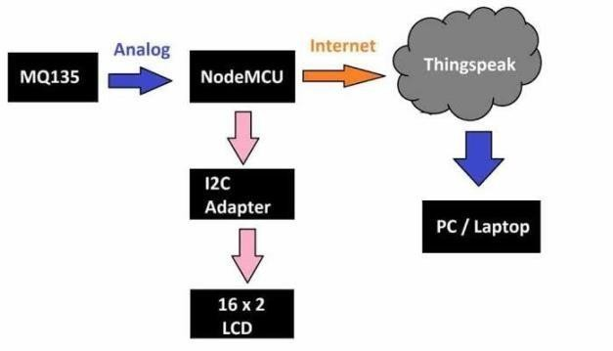

**Figure 1: Block Diagram**

# CIRCUIT DIAGRAM

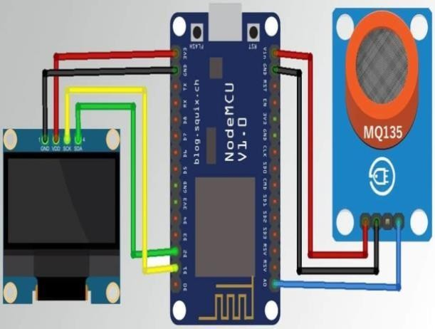

1. **Components:**

**Figure 2 :Schematic diagram**

# HARDWARE REQUIREMENTS:

* ESP8266NOD MCU BOARD
* MQ135 SENSOR
* BREAD BOARD

# SOFTWARE REQUIREMENTS:

* Thing speak cloud
* Arduino IDE

# ESP8266NOD MCU BOARD:

The Node MCU may be a standard development board supported the ESP8266. It options not solely the ESP12 module (which contains the ESP8266 SOC), however it conjointly comes with a USB connecter and breadboard-friendly pins, to create it straightforward for you to check and develop comes on the ESP8266

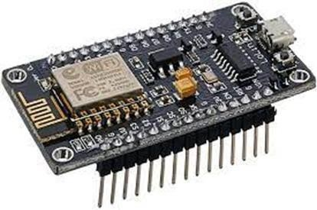

### Figure 3 : ESP8266NOD MCU BOARD

**OLED DISPLAY:**

OLED display technology uses organic (carbon-containing) compounds that emit light-weight once a current is gone through it. OLED materials may be tiny molecule organic material or chemical compound material. OLED displays area unit famed for his or her high image quality, flexibility, and lower power consumption beside its premium value purpose

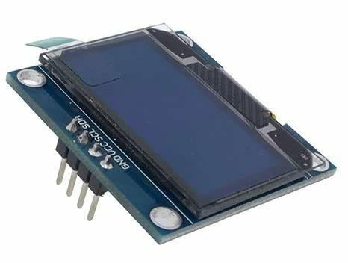

### Figure 4: OLED DISPLAY

**MQ135SENSOR:**

The MQ-135 Gas sensor can detect gases like Ammonia (NH3), sulfur (S), Benzene (C6H6), CO2, and other harmful gases and smoke. Similar to other MQ series gas sensor, this sensor also has a digital and analog output pin. When the level of these gases go beyond a threshold limit in the air the digital pin goes high.

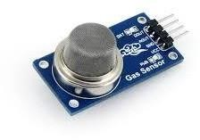

### Figure 5:MQ135 SENSOR

**BREARD BOARD:**

A bread board is just a board for prototyping or building circuits on. It permits you to position parts and connections on the board to form circuits while not attachment. The holes within the bread board pay attention of your connections by physically holding onto elements or wires wherever you place them and electrically connecting them within the board. the benefit of use and speed square measure nice for learning and fast prototyping of easy circuits.

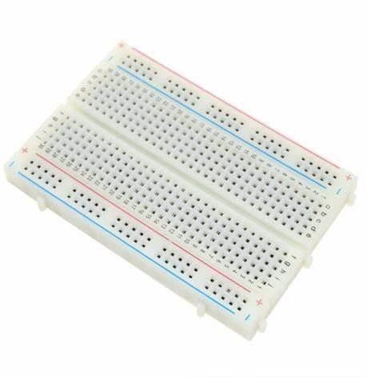

**Figure 6:Bread board**

# Arduino IDE:

The Arduino IDE is associate degree ASCII text file code, that is employed to write down and transfer code to the Arduino boards. The IDE application is appropriate for various operational systems like Windows, Mac OS X, and Linux.

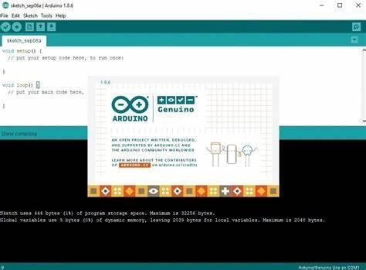

### Figure 7 : Arduino IDE

**Thing Speak cloud:**

It is an IoT analytics platform service that allows you to aggregate, visualize, and analyze live data streams in the cloud. You can send data to ThingSpeak from your devices. Visualize your sensor data in real-time. Aggregate data on-demand from third-party sources. Easily configure devices to send data to ThingSpeak using popular IoT protocols.

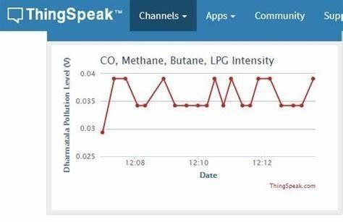

### Figure 8: Thing speak cloud

1. **Work flow PHASE - 1:**

Detection of Air waste Level Indicates the first section of the project. An IOT primarily based pollution detection kit is developed. It deals with the operating of MQ135 gas sensing element and its method of aggregation information and causation it to the nodeMCU board. The MQ-135 gas sensing element has an inbuilt resistance (sense resistor) that changes its resistance price consistent with the concentration of gas. If the gas concentration is high, the resistance decreases, and if the gas concentration is low, the resistance will increase. The data can passed to the nodeMCU board consistent with the sensors output.

### PHASE –2

Creating the interface is that the stage involves the clarification of the varied elements for nonmandatory performance. MCP3008 could be a ten bit device that is tag to convert analog information to digital with on-board sample and hold electronic equipment. the information collected from the gas sensing element is keep, processed and monitored by the nodeMCU board . the most work of the board is to transmits the signal to the cloud. The board is connected through WLAN.

### PHASE - 3:

The third section is wherever the output of the total system is discovered . it's the ultimate stage of the method. during this the output is received from the modeMCU board through WLAN. The output is displayed within the cloud. during this we've got used thingspeak cloud. And used embedded computer program for the method. The output may be displayed in varies technique. we have a tendency to displayed the output within the graph format. The x axis is time and therefore the y axis is pictured as PPM(parts per million).

# Conclusion

In this project IOT based on display of Air Quality Index (AQI). From the information obtained from the project, it is possible to calculate Air Quality in PPM. The disadvantage of the MQ135 sensor is that specifically it can‘t tell the Carbon Monoxide or Carbon Dioxide level in the atmosphere, but the advantage of MQ135 is that it is able to detect smoke, CO, CO2, NH4, etc harmful gases. After performing several experiments, it can be easily concluded that the setup is able to measure the air quality in ppm, The results obtained from the experiments are verified through Google data. Moreover. However, the project experiences a drawback that is it cannot measure the ppm values of the pollutant components separately. This could have been improved by adding gas sensors for different pollutants. But eventually, it would increase the cost of the setup and not be a necessary provision to monitor the air quality. Since it‘s an IOT-based project, it will require a stable internet connection for uploading the data to the Think Speak cloud. Therefore, it is possible to conclude that the designed prototype can be utilized for air quality of the surrounding atmosphere successfully.

# References

1. J. J. Caubel, T.E. Cados, T.W.Krichstetter,(2018)‗A New Black Carbon detector for Dense Air Quality observance Networks‘, IEEE.
2. Harsh Gupta,Dhananjay Bhardwaj, Himanshu Agrawal, Vinay Anand Tikkiwal, ArunKumar,(2019)‗An IOT based mostly pollution observance System for sensible Cities‘, ICSETS.
3. G. Lo Re, D. Peri, S. D. Vassallo, (2013) ‗A mobile application for assessment of pollution exposure‘, IEEE.
4. Monika Singh, Misha Kumari, PradeepKumarChauhan, (2019) ‗IoT based mostly pollution observance System ‘, International analysis Journal of Engineering and Technology, IRJET. 5.Nitin SadashivDesai,JohnSahayaRaniAlex,(2017)‗IOT based mostly pollution observance and predictor system on hound Bone Black‘, International Conference on Electronic Technologies, ICNET.
   1. K. S. E. Phala, A. Kumar, and Gerhard P. Hancke, ‗Air Quality observance System supported ISO/IEC/IEEE 21451 Standards‘, IEEE.
   2. Poonam Pal, Ritik Gupta, Sanjana Tiwari, Ashutosh Sharma, (2017) ‗IOT based mostly pollution observance system‘ International analysis Journal of Engineering and Technology IRJET.
   3. Rajat Sankhe, Pravin Shirodkar, Avinash Nangare, Abhishek Yadav, Gauri Salunkhe (2017)

‗IOT based mostly Air and pollution observance System International Journal of Engineering analysis & Technology IJERT.

* 1. Swati Dhingara, Rajasekhara baboo Madda, Amir H. Gandomi, Rizwan Patan, Mahmoud Daneshmand, (2019) ‗Internet of Things Mobile – pollution observance System (IOT)‘, IEEE.
  2. Yamunathangam, K. Pritheka, P. Varuna, (2018) ‗IOT Enabled pollution observance and Awareness Creation System‘, International Journal of Recent Technology and Engineering, I

# National Conference

On

# INNOVATIVE ENGINEERING TECHNOLOGIES 2022

**(NCIET 2022)**

## (Hybrid Mode)

19th December 2022

**Registration Form**

Name Designation Organization Official Address

Mobile/Telephone

E-mail

**Title of the Paper**

**Author(s) Payment Details**

Amount: UPI Transaction ID

Date Signature

# National Conference

On

# INNOVATIVE ENGINEERING TECHNOLOGIES 2022

**(NCIET 2022)**

## (Hybrid Mode)

19th December 2022

Organized by

# Faculty of Engineering Department of Electronics and Communication Engineering



### Karpagam Academy of Higher Education

(Deemed to be University) (Established Under Section 3 of UGC Act 1956)

(Accredited with A+ Grade by NAAC in the Second Cycle)

Pollachi Main Road, Eachanari Post Coimbatore – 641 021, INDIA

Phone: 0422-2980011, 2980012, 2980013

Email: [info@kahedu.edu.in](mailto:info@kahedu.edu.in) Web: [www.kahedu.edu.in](http://www.kahedu.edu.in/)

### ABOUT KARPAGAM ACADEMY OF HIGHER EDUCATION

Karpagam Academy of Higher Education (KAHE) established under Section 3 of UGC Act 1956 is approved by Ministry of Human Resource Development, Government of India. Dr. R. Vasanthakumar, the president of Karpagam Charity trust (KCT), Philanthropist, Industrialist, Entrepreneur and Culture Promoter. Contemporary infrastructure, modern teaching methodologies, career-oriented training, excellent placements and the finest faculty have always become the Karpagam’s hallmark. Besides technical expertise, Karpagam Academy of Higher Education (KAHE) has made a mark since its inception by developing communication and soft skills, ensuring enlightening knowledge, extending holistic education and creating a strong value system. Karpagam Academy of Higher Education is setting new benchmarks in the educational sphere.

### ABOUT THE DEPARTMENT

The department of Electronics and Communication Engineering was established in the year 2009. The research specializations of the department are VLSI Design, Wireless Communications, Embedded Systems, Robotics, Digital Image Processing, Neural Network, Human Machine Interface, Digital Signal Processing, etc. Our department has a very good infrastructure for pursuing R & D in the areas of Embedded System Design, VLSI Design using Cadence and Bio Signal & Image Processing. We also have specialized labs like Embedded Systems Lab sponsored by Texas Instruments, Full-fledged Cadence Lab for VLSI Design and development of products on Low power.

### ABOUT THE CONFERENCE

The objective of the conference is to impart and share knowledge of research & development works between academicians, scientists, industrial personnel, research scholars & student community in various fields of embedded and communication systems. The conference aims to bring scientists, R&D professionals, academicians & industrialists to highlight the Advancements in the field of Electronics and Communication Engineering.

### CALL FOR PAPERS

National conference is a premier forum for the presentation of technological advances and research results. Topics of submission include interest for the following, but not limited to,

* + Internet of Things (IoT)
  + Embedded System
  + Wireless Sensor Networks
  + Advanced VLSI
  + Integrated Circuit Design
  + Smart Antenna
  + Cloud Computing
  + Data Analytics
  + Plasma Antenna
  + Carbon Chips
  + Nanomachines
  + Zigbee Networks
  + RFID Technologies
  + Organic LED’s

### DATES TO REMEMBER

|  |  |
| --- | --- |
| Submission of Abstract | 16.12.2022 |
| Intimation of Acceptance | 17.12.2022 |

**REGISTRATION FEE**

**A/C NO** 170002000000959

|  |  |
| --- | --- |
| Academicians/ Research Scholars/ UG & PG Students/ Industrial Person | Rs. 100 /- |

**A/C Holder Name:** Karpagam Academy of Higher Education

**IFSC :** IOBA0001700

**Branch :** Seerapalayam branch

### GUIDELINES FOR CONTRIBUTORS

Authors are requested to submit the soft copy of the paper in IEEE format Times New Roman with a font size of 10 not exceeding 8 pages to the following email address

### Email : [ncietconference2022@gmail.com](mailto:ncietconference2022@gmail.com) Mobile No: 7708888550, 7904710178

**ADDRESS FOR CORRESPONDENCE**

To

The Organizing Secretary

National Conference on Innovative Engineering Technologies 2022 (NCIET 2022)

Faculty of Engineering Department of ECE

Karpagam Academy of Higher Education Coimbatore

### ADVISORY COMMITTEE

1. Dr. V. Karthikeyan, Assistant Professor, Dept. of Electrical Engineering,

NIT Calicut, Kozhikode

1. Dr. V. R. Vijayakumar, Associate Professor & Head, Department of Electronics and Communication Engineering, Anna University, Coimbatore

### ORGANIZING COMMITTEE

**Chief Patron**

### Prof. Dr. B. Venkatachalapathy

Vice Chancellor

Karpagam Academy of Higher Education

### Dr. M. Palaniswamy

Registrar

Karpagam Academy of Higher Education

### Patron

**Dr. A. Amudha**

Dean i/c

Faculty of Engineering

Karpagam Academy of Higher Education

### Convenor

**Dr. K. G. Dharani** Head of the Department Department of ECE

Karpagam Academy of Higher Education

### Organizing Secretaries

Mr. P. Suseendhar AP/ECE

Ms. A. Monika Vishnuvarthini AP/ECE Mr. G. Aravindh AP/ECE

Mr. G. R. Mahendrababu AP/ECE Dr. M. Kavitha AP/ECE

Ms. P. Sasikala AP/ECE

Mr. R. Naveenkumar AP/ECE Ms. R. J. Abinaya AP/ECE

